Lecture 17 OUTLINE
Foundational Theories of Social Order/Organization 2

IMAGES OF SOCIAL ORDER

WHO GETS WHAT AND WHY?
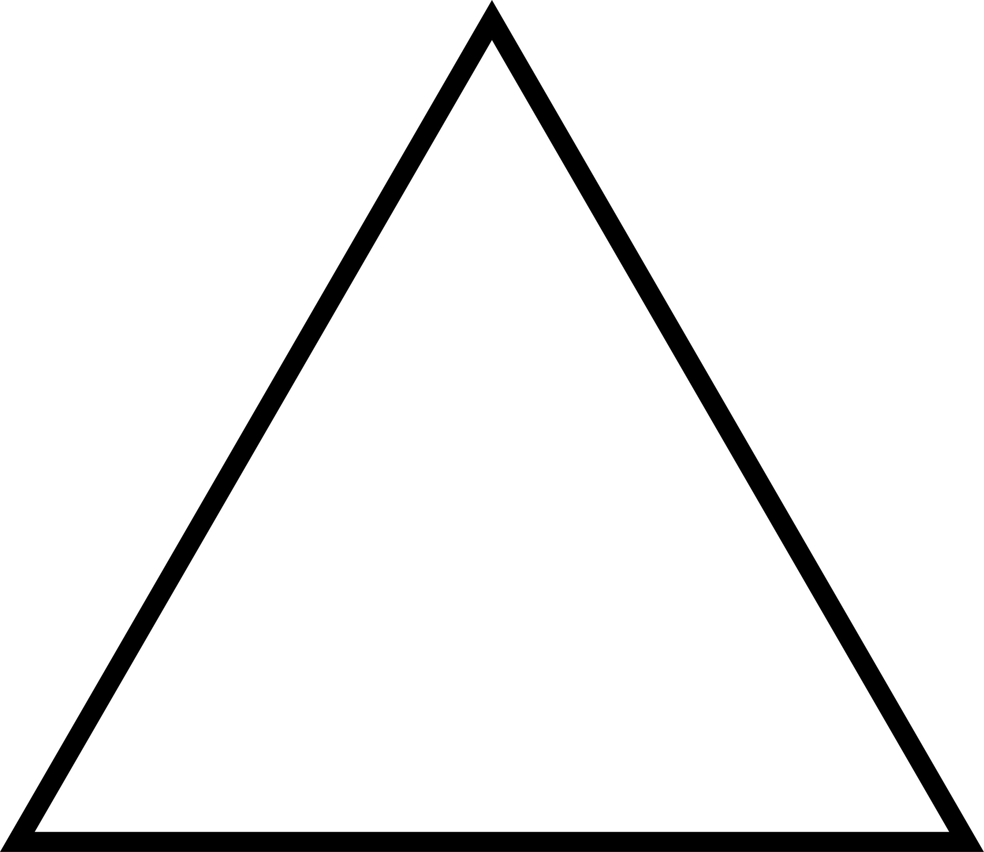

hierachy inequality power domination oppression conflict antagonism

HOW ARE INDIVIDUALS ATTACHED TO THE COLLECTIVE?
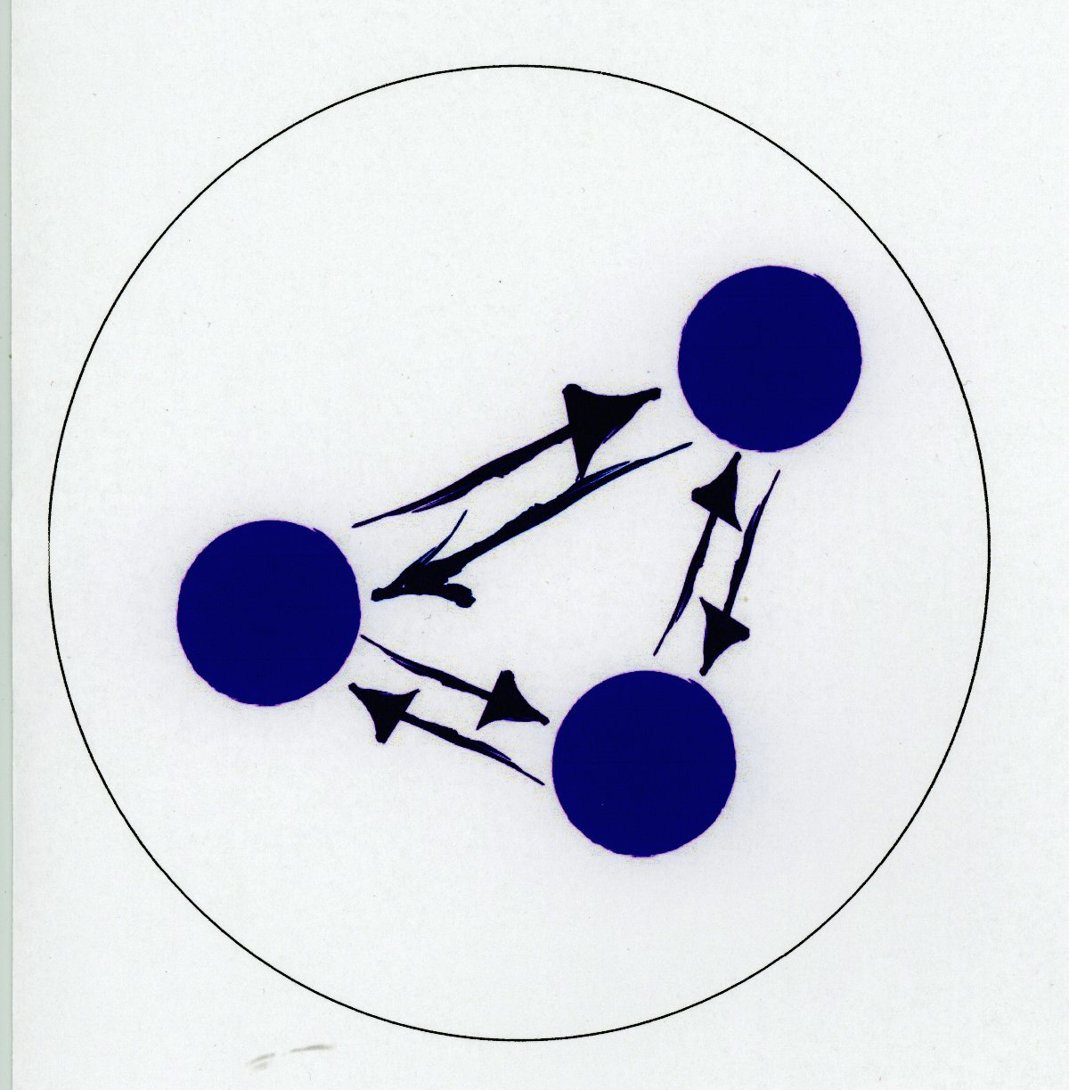
belonging, security, cooperation, dependence/interdependence,
shared consciousness

ON WHAT BASIS ARE MEMBERS ORIENTED TO ACT?



meaning, understanding, social location, intersections
Marx, Durkheim, Weber, Gilman

CENTRES OF GRAVITY

These four classical social theorists focused on the social order that was emerging in European nation states during the 19th century.

A summary of how each of these theorists defined the centre of gravity of social order/organization.

For Marx – the key to understanding social order is the economic relationships that prevail in a particular society.

For Durkheim-the key to understanding social order is the moral bonds that tie individuals to the collective.

For Weber - the key to understanding social order is social actors' oriented and purposeful social actions.

For Gilman - an additional and essential key for understanding social order is the sex-based (gender-based) relationships that prevail in a particular society

