Lecture 19: Foundational Social Theorists 3
OUTLINE

Max Weber (1864-1920)

1.One way of looking at Weber’s sociology is to see it as a dialogue with Marx and Durkheim.

(a) Weber did not think that there was one set of social laws that would explain all of social life for all times.

(b) Things could happen in social life that could not be predicted.

“[The social world] presents an infinite multiplicity of successively and coexistently emerging and disappearing events, both ‘within’ and ‘outside’ ourselves.” (In the reading kit, quoted from “Sociology and Science” in Sociological Writings, p. 248)

(c) Weber believed that the emergence of particular kinds of social orders or societies is highly contingent.

(d) Weber believed that the subject matter of sociology is different from that of the natural sciences.

“We can accomplish something that is never attainable in the natural sciences, namely the subjective understanding of the action of … individuals. The natural sciences on the other hand cannot do this, being limited to the formulation of causal uniformities in objects and events. This additional achievement of explanation by interpretive understanding, as distinguished from external observation, is of course attained only at a price — the more hypothetical and fragmentary character of its results.” (In the reading kit, quoted from “Sociology and Science” in Sociological Writings, p. 240)

2. Weber focused on many dimensions of social life rather than focusing on one primary dimension: the economic, as in Marx, or the moral bonds that hold members of society together, as in Durkheim.

(a) Weber's view of society is as a collection of overlapping social fields.

(b) Weber therefore argued that modern people act from a multiplicity of “spaces.”

3. For Weber, sociology’s project is to provide a basis for understanding social actions. “Why do people act as they do?”

4. Weber argued that in order to understand why people act as they do we have to begin with how people understand the situations they are living in.

“Action is social insofar as, by virtue of the subjective meaning attached to it by the acting individual (or individuals) it takes account of the behaviour of others and is thereby oriented in its course.” (In the reading kit, quoted from “Sociology and Science” in Sociological Writings, p. 228)

5. Weber thus emphasised the importance to sociology of the principle of “verstehen” or “understanding."

6. By the actor’s orientation, Weber is referring to orientations that are shared with other actors– they don’t belong only to a particular individual.

“Thus, for a science that is concerned with the subjective meaning of action, explanation requires a grasp of the complex of meaning in which a course of understandable action thus interpreted belongs.” (In the reading kit, quoted from “Sociology and Science” in Sociological Writings, p. 233)

7. Weber’s method of doing sociology was to analyse the factors that motivated certain actions.

“ … concepts of collective entities [i.e., nation, family, corporation] which are found both in common sense and in juridical and other forms of technical thought, have a meaning in the minds of individual persons, partly as of something actually existing, partly as something with normative authority. Actors thus in part orient their action to them, and in this role such ideas have a powerful, often a decisive, causal influence on the course of action of real individuals.” (In the reading kit, quoted from “Sociology and Science” in Sociological Writings, p. 239)
8. A good illustration of this approach is seen in his famous study of the Protestant Ethic and the Spirit of Capitalism.

9. Because different societies work differently, Weber argued that sociologists should attempt to examine the society that is the home base of the individuals we are attempting to understand, rather than trying to create theories that would explain how society in general works.

10. He focused his research on the structure and working of the society that was his home base, the capitalist or market society.

(a) He investigated the actions of persons who live in a market society.

(b) Contrasting with Marx, he argued that different types of human social actions could be explained or accounted for in terms of different factors:

(c)He disagreed with the central weight that Marx assigned to economic action. He believed that other realms of social life generated their own hierarchical social relationships that operated in very different ways than the economic realm.

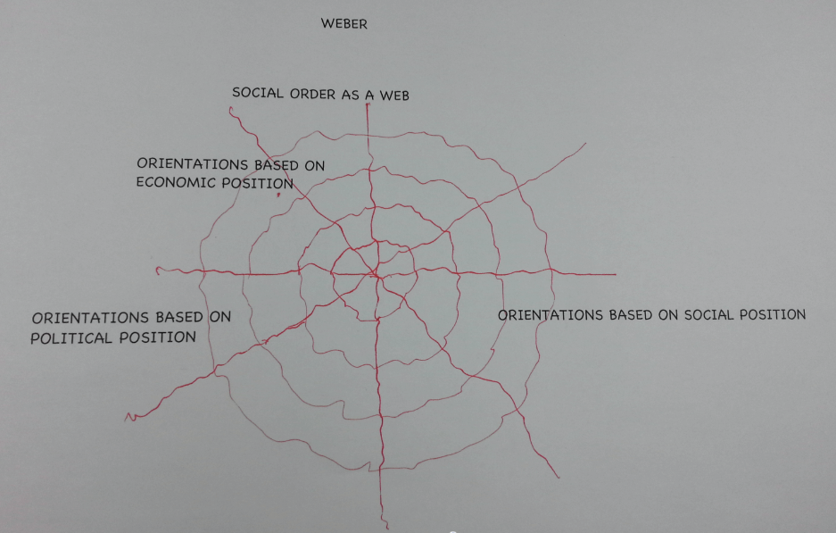

11. Weber argued that sociologists face special difficulties in understanding their subject matter; He aimed for as much understanding of human action as possible but always recognised that it would be partial and incomplete.

“[The social world] presents an infinite multiplicity of successively and coexistently emerging and disappearing events, both ‘within’ and ‘outside’ ourselves.” (In the reading kit, quoted from “Sociology and Science” in Sociological Writings, p. 248)

12. Weber’s influence on sociology has gone in many directions

Charlotte Perkins Gilman (1860-1935)

Intro:
An important thing to note about this social theorist, as well as that she was a woman, is that she was born and lived in the U.S.

1. Gilman believed that an essential key for understanding social order is the sex-based (gender-based) relationships that prevail in a particular society.

2. Gilman was especially influenced by a theory at the time called "gynaecocentric theory" which argued that the female is the original human type and the progress of humanity depends upon her development.

3. Gilman was also influenced by the evolutionary thinking of her time. Human beings evolving consciousness gives them the capacity to increasingly control their evolution.

4. Gilman thus believed that the imbalances between males and females all of the social problems that result from them can be corrected.

5. Thus Gilman's social theory tries to reveal how societies are organized and how they do function, and on the other hand, how they could be organized and could function.

6. For Gilman, the focus of sociology is "human social relation."

"Our whole social structure ... rests in reality on social relationships." (Not in the reading kit, Gilman, Charlotte P. 1903. The Home: Its Work and Influence. New York: Macmillan: 21.)

7. What she means by human social relation is "the process of reciprocal action and inter-psychic orientation among individuals within the context of a shared collective membership." (Paraphrase based on Gilman, Charlotte P. 1900. Concerning Children. Boston: Small and Maynard: 298.)

8. Gilman believed that productive activity can be a source for great joy and satisfaction because it expresses human beings' sociality and creativity. But human relations in the economic order have become corrupted by "excessive sex distinctions.

9. Gilman argues that excessive sex distinction (we would say gender-distinction today) goes far beyond what is necessary for biological reproduction.

10. Gilman thus developed the term "sexuo-economic relation" to refer to the basic inequality in society that results from excessive sex distinction.

"We are the only animal species in which the female depends upon the male for food, the only animal species in which the sex-relation is also an economic relation." (In the reading kit, pge 384)

12. For Gilman, the sexuo-economic relation is central to her critique of American society in the 19th and early 20th century, Sex distinction creates a social relation of subordination and domination.

"Their labour is the property of another. They work under another's will; and what they receive depends not on their labour, but on the power and will of another." (In the reading kit, pge 384)

13. Gilman argues that the sexuo-economic relation corrupts human sociality.

14. As well, sexuo-economic relation creates an androcentric culture.

15. Gilman believes that it is possible for us to liberate ourselves from the sexuo-economic relation.

